**Clarification required in Shopping Cart**

**Add to Cart**

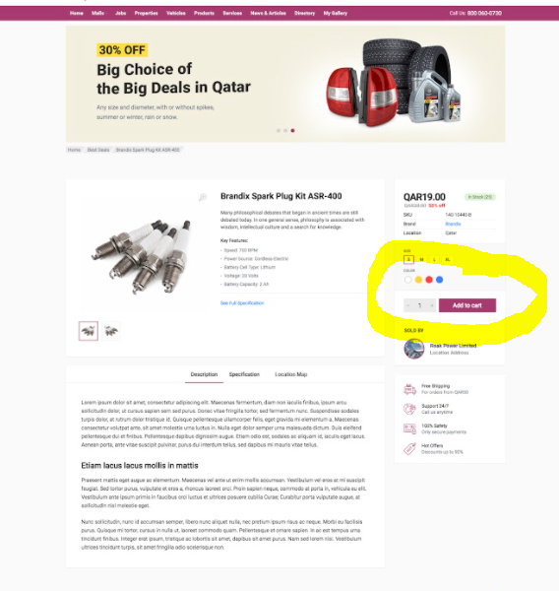

* Here we will be using below apis to add into cart
* <http://175.41.176.135:3000/apidoc/#api-Shopping_Cart-PostV1UsersUser_idCart>
* <http://175.41.176.135:3000/apidoc/#api-Shopping_Cart-PostV1UsersUser_idCartService>

**Shopping Cart**

* Here we need to display Products and services in two different tabs, without any checkboxes.
* <http://175.41.176.135:3000/apidoc/#api-Shopping_Cart-GetV1UsersUser_idCart>
* <http://175.41.176.135:3000/apidoc/#api-Shopping_Cart-GetV1UsersUser_idCartService>
* Quantity part is there, do we have separate API for product and services to update based on the quantity(Currently only Product cart update is there)
* <http://175.41.176.135:3000/apidoc/#api-Shopping_Cart-PutV1UsersUser_idCart>
* In Displaying the Cart Total, From the API, Do we get the shipping charge?
* Products and services, both together will do the checkout?

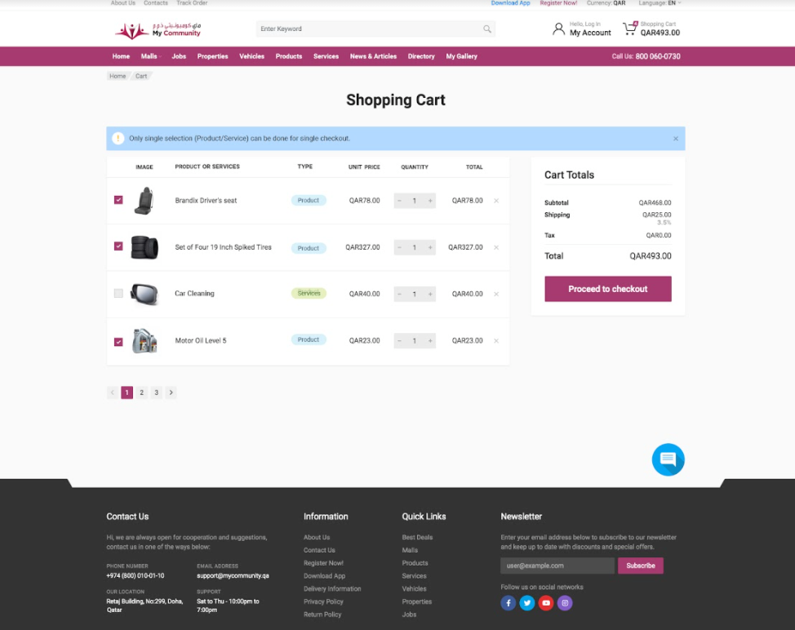

* Here we will be displaying the products added in the cart(both products and services will be listing), So here below two api will be using
* <http://175.41.176.135:3000/apidoc/#api-Shopping_Cart-GetV1UsersUser_idCart>
* <http://175.41.176.135:3000/apidoc/#api-Shopping_Cart-GetV1UsersUser_idCartService>
* What happens when we click Place order button?

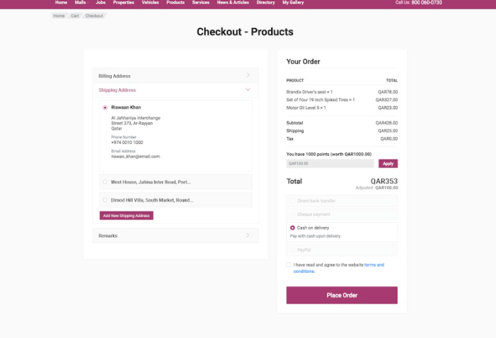

**Best Deal**

* Clarification Required
* We are not creating any best deals(Product/Services) from our web

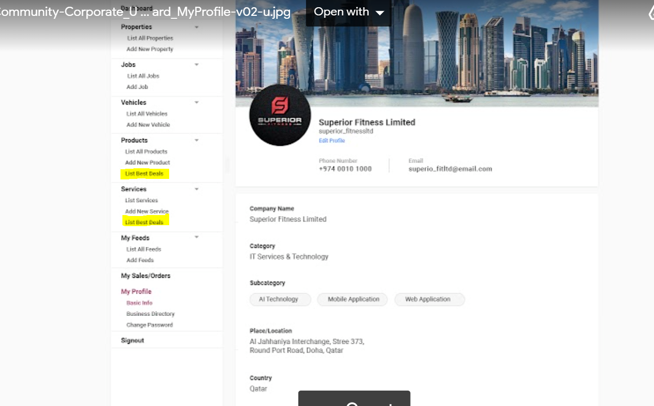

* Which API are we using to list the best deals in Products and Services of dashboard?

**Redeem Points**

* As discussed in last meeting, we will be showing the redeem points in below screen**.**
* **How we get the redeem points?**

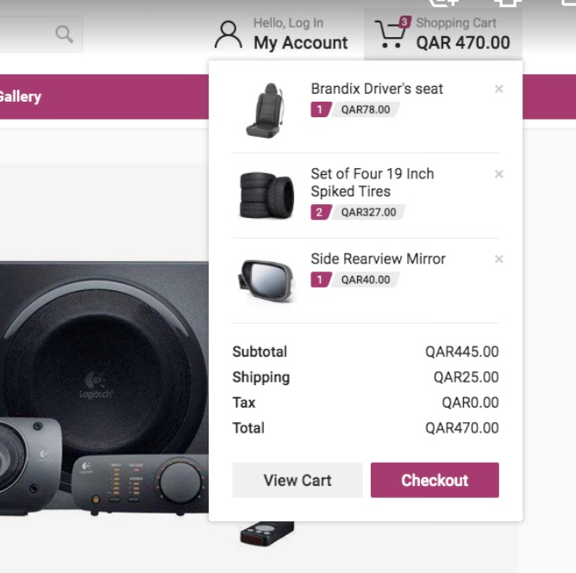

**Profile Page Details**

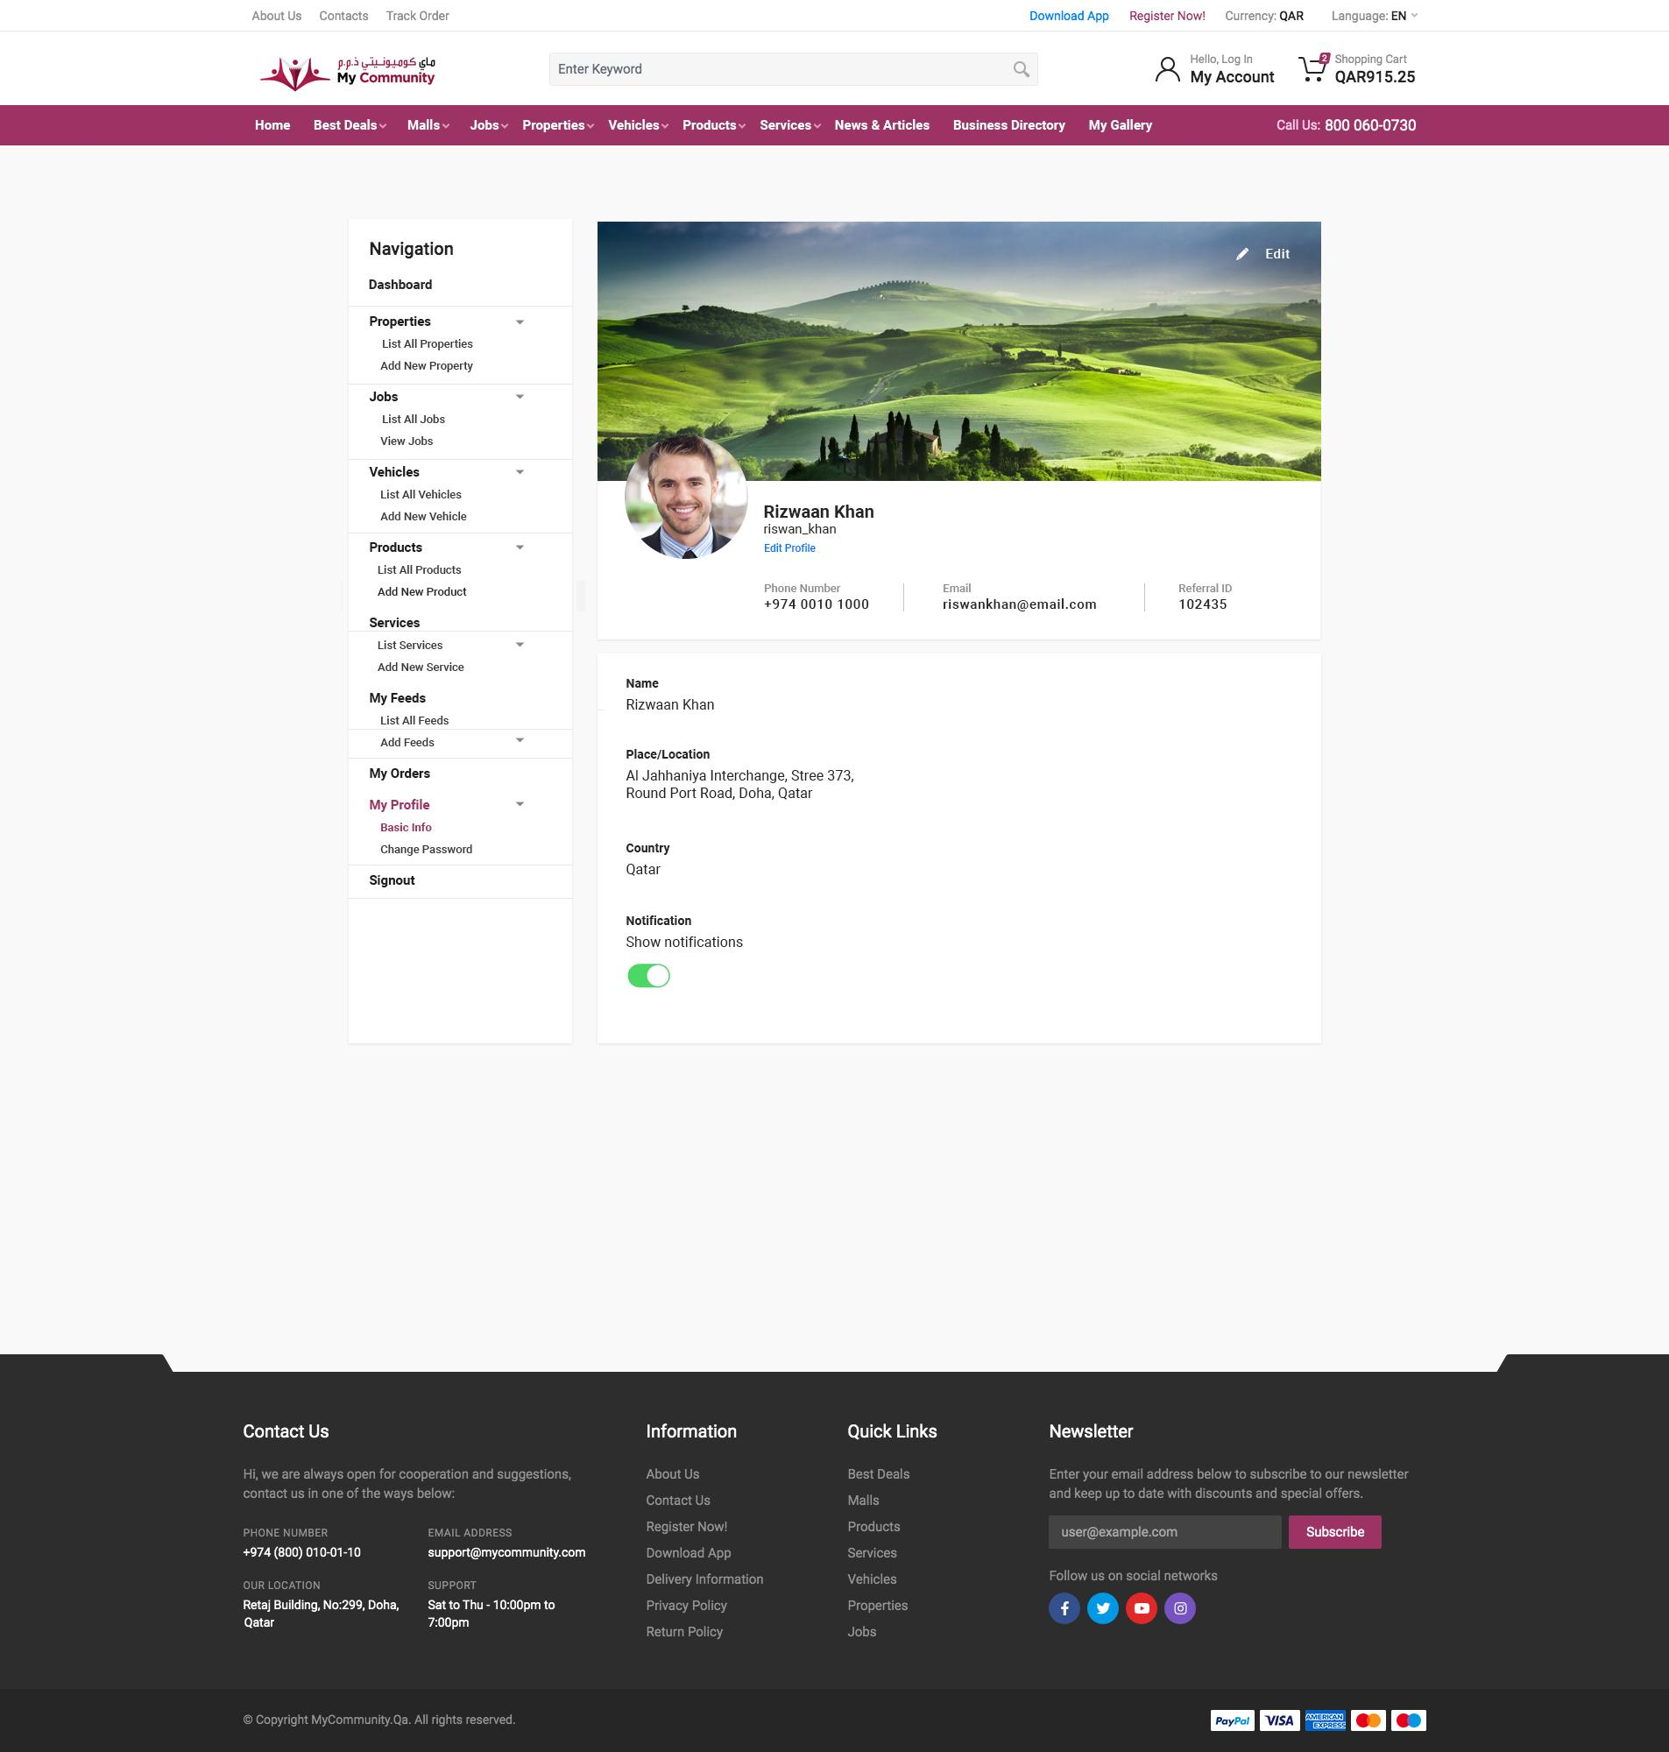

* <http://175.41.176.135:3000/apidoc/#api-User_Accounts-GetV1UsersProfilesMe> - User details- no categoryName, subCategoryName and industryName. No location details in both corporate or individual instead we are only getting the ID of it, so we need to fetch each separately. It can delay page loading time more. It would be better to get in a single API with name and ID together
* Notification individual update API is needed (currently API available to update all fields in update user, but with mandatory fields in it)

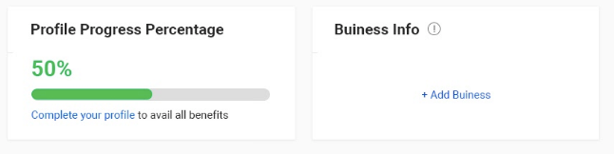

* From where we can get the profile progress (currently not available with API)
* Need more clarification in business info (what is the actual functionality of this business info part in this design)

**Vehicle Public Page**

* In-vehicle details page new design need to show the profile pic of the dealer in the contact part.

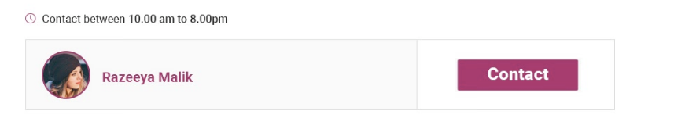

* <http://175.41.176.135:3000/apidoc/#api-Vehicles-GetV1VehiclesSlugsSlug> - Vehicle details on public page- no contact profile pic.